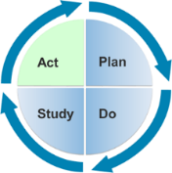
Handout 1.5 Interaction – Observation Form

Child:
Date:
Goal:

Measureable Objectives:

Objective | 1 | 2 | 3 | 4 | 5
Free Play
Personal Care/ Toileting
Mealtime
Outdoors
Outings
Other
Notes

Credit: Adapted from CONNECT (2009). Handout 1.14: Observation Form.

