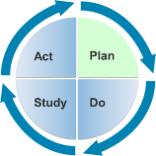

Learning Guide 3.3 Environment-
Gathering Information

Objectives
- Understand the components of the child’s natural learning environment.
- Understand how the environment can serve as an intervention strategy to promote access and participation of all children, especially children with disabilities.
Related Content: Module 3, Lesson 2 Gathering Information
Instructional Method: Discovery; Structured Exercise
Level: Intermediate
Estimated Time Needed: 10 min. instructor preparation; 20 min. learner activity

Description
In this activity, learners will brainstorm the different aspects of the physical, temporal, and social environments that can be adapted for children with disabilities. Learners will then practice adapting physical, temporal, and social environments to promote the access and participation of all children.

Materials/Resources
- Learning Guide 3.2 “Components of the Environment” Brainstorming Web
- Learning Guide 3.2 Activity Handout

Facilitator Instructions
- With the whole group, create a brainstorming web (on the board, SmartBoard, or using a Web-based brainstorming tool) of the various components of the physical, temporal, and social environments. (See M3L2 Brainstorming Web for sample ideas).
- Individually or in small groups, have learners select one component of each environment (physical, temporal, and social) and describe a possible accommodation or modification that would support participation and access for children.
- Allow learners to share modifications and accommodations with the whole group. Provide feedback.

Suggested Assessment
Performance Indicator: Learners will understand the components of the natural learning environment and how accommodations and modifications to the natural learning environment promote access and participation for all children.

If the learner… | Then provide feedback…
Cannot identify components of the environment | Refer the learner back to Module 3, Lesson 2
Cannot identify accommodations or modifications to make to the natural learning environment | Provide additional resources and examples of accommodations and modifications  See: http://ectacenter.org/decrp/topic-environment.asp

Distance Learning Tips
- Use a Web-based brainstorming tool that multiple users can collaborate on to create the web of components of the natural learning environment. (Examples: bubbl.us, xmind.net, freemind.sourceforge.net/)
- Learners can work individually to complete M3L2 Handout.
- Provide individual feedback in a timely manner.

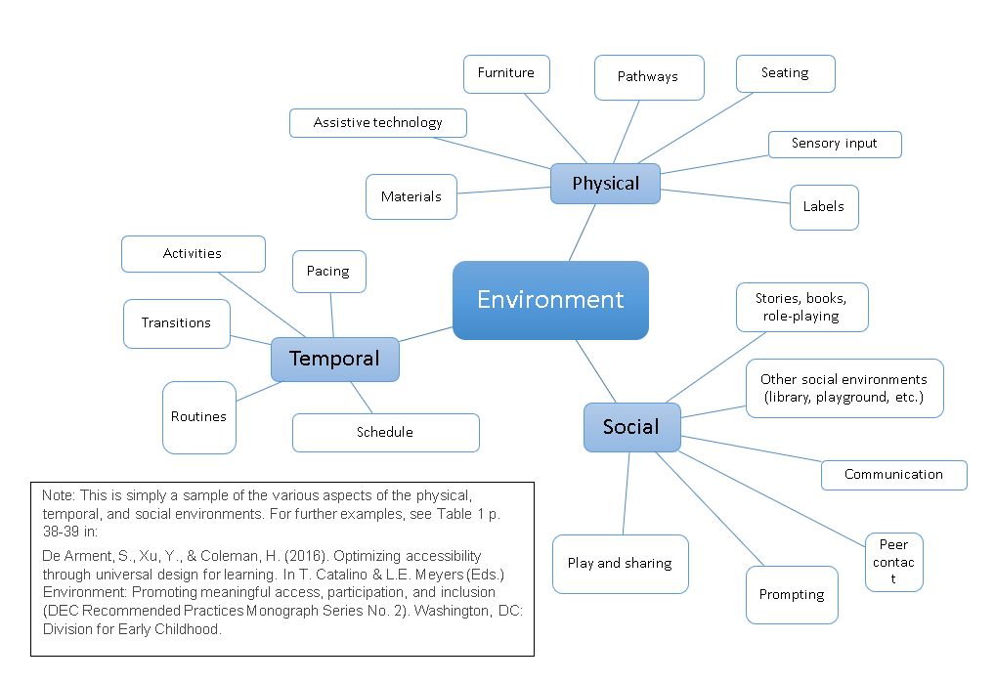

Learning Guide 3.2 Handout

Name(s):
Date:

Directions:
Environment | Describe Accommodation/ Modification | How will it promote access? | How will it promote participation?
Physical
Temporal
Social

Learning Guide 3.2 Handout - SAMPLE ANSWERS

Name(s):
Date:

Directions:
Environment | Describe Accommodation/ Modification | How will it promote access? | How will it promote participation?
Physical | Offer multiple seating options (e.g., floor, carpet, chair) during morning circle time. | Modification will allow students with differing needs (such as physical disabilities) to access group activities. | Modification will allow student to make a choice for participation in circle time.
Temporal | Represent the daily schedule in a concrete way by using pictures on a ring for a child to hold. | Accommodation will allow student to anticipate the daily activities and transition easily so as to access activities. | Accommodation will promote student’s participation by easing transitions between activities.
Social | Provide ample materials such as cars in the block area for many children to play together. | Modification will allow students to access social play through availability of multiple and various materials. | Modification will promote a student’s participation by providing an accessible and non-threatening way to engage in social environments.

