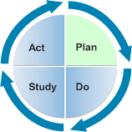

Learning Guide 1.3 Interaction-

Gathering Information

Objectives
- Identify nonverbal and verbal cues and interests of infants, toddlers, and preschoolers.
- Practice using observation to identify and interpret a child’s nonverbal and verbal signals and interests, abilities, and emotions.
Related Content: Module 1, Lesson 2 Gathering Information
Instructional Method: Discovery; Structured Exercise
Level: Intermediate
Estimated Time Needed: 10 min. instructor preparation; 20 min. learner activity

Description
In this activity learners will examine photographs of young children engaged in activity to identify cues and interpret these signals to determine interest, abilities, and emotions.

Materials/Resources
- Photographs of young children (infants, toddlers, and preschoolers) engaged in activity. [Some attached, more can be found with a Google Images search. Keywords: infant playing, toddler playing, preschooler playing, child playing, etc.]
- Learning Guide 1.3 Activity Handout

Facilitator Instructions
- Have learners break into pairs.
- Give each pair of learners a photograph of a child engaged in activity. Ask the learners to discuss the following questions (found on handout):
  - What do you observe the child doing? Be descriptive and objective!
  - What nonverbal (or verbal if using video) cues are occurring?
  - How do you interpret these cues to determine the child’s interests, abilities, and/or emotions?
- Have each pair share their photograph and their observed cues and interpretations of those cues to determine the child’s interests, abilities, and emotions.
- Provide feedback as needed.

Suggested Assessment
Performance Indicator: Learners will be able to observe and interpret children’s interests, abilities, and emotions.

If the learner… | Then provide feedback…
makes an incorrect or erroneous observation statement | that helps the learner attend to the child’s gaze, gesture, hand/body position, facial expression, etc.
interprets the child’s interest, ability, or emotion inappropriately | that helps the learner connect verbal and nonverbal cues to more appropriate interpretations.* **  *Interpretations are just guesses so there can be multiple interpretations for an observed cue.  **Also, note that interpretations of behavior are highly contextualized based on the observer’s background and experience. Take this into consideration when evaluating learner’s interpretations.

Distance Learning Tips
- Learners can work individually.
- Have learners search the Internet for their own photos and videos to use for the activity. Then have the learners upload these photos and/or videos to the online learning platform for the share portion of the lesson.
- Provide individual feedback in a timely manner.

A  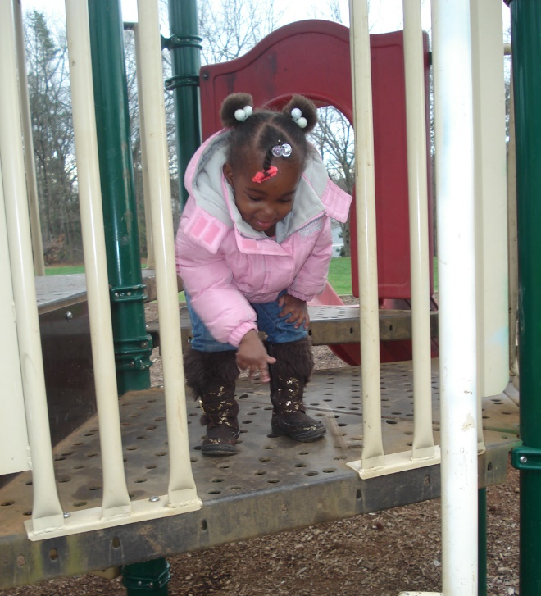 | B  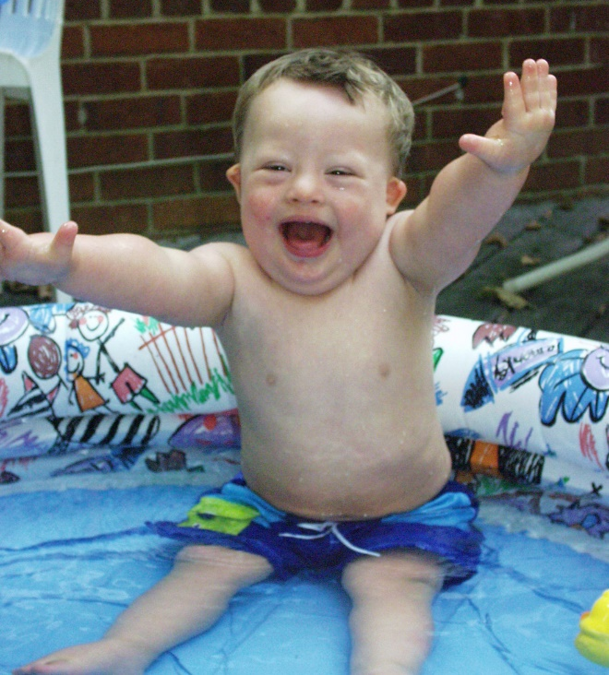
C  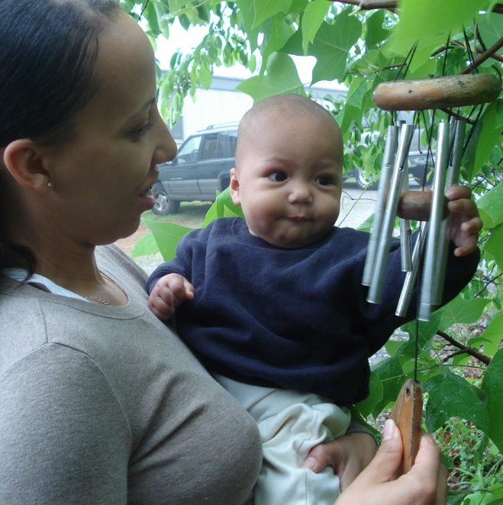 | D  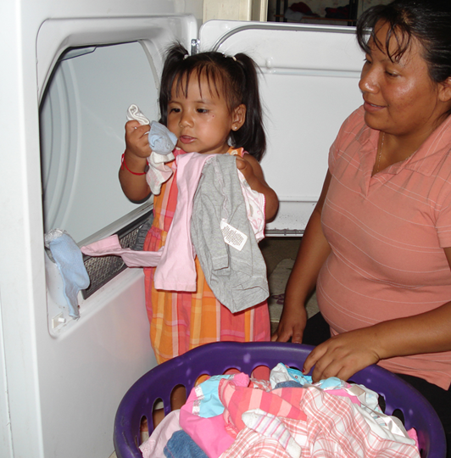

Learning Guide 1.3 Activity Handout

Name(s):
Date:

Directions:
Carefully examine the target child in the photograph (or video) and answer the following questions.

- What do you observe the child doing? Be descriptive and objective!

- What nonverbal (or verbal if using video) cues are occurring?

- How do you interpret these cues to determine the child’s interests, abilities, and/or emotions?

