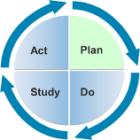

Learning Guide: Embedding the Modules

into Existing Coursework and Practicums

Objectives
- Discover how to embed DEC Recommended Practices Modules into existing coursework.
For illustration purposes, we have used Module 1: Interaction to show some of the different ways the RPM Modules can be incorporated into coursework and practicum experiences to enrich, extend, and support work already being carried out by professors, instructors, and supervisors.

Examples of Courses
College/University faculty may embed some or all of Module 1: Interaction into lectures, readings, or small assignments. Sample courses where Module 1 might be appropriate are:

Foundations Courses
- Teaching Exceptional Children
- Early Intervention for Young Children with Special Needs
- Infant and Toddler Care
- Families and Teams – Sociocultural and Interdisciplinary Perspectives
- Creating Learning Environments
- Creative Expression and Play
- Educational Psychology: Principles of Classroom Learning

Methods Courses
- Effective Instruction in Inclusive Classrooms
- Learning and Development in a Social Context: Preschool and Primary Years
- Learning and Teaching in the Early Childhood Classroom

Practicum Courses
- Preschool/Kindergarten Internship
- Early Childhood Internship
- Infants/Toddlers/2s Internship and Seminar

Examples of Assignments
These are examples of actual assignments where Module 1: Interaction could help inform or frame the work of the university students.

Child Assessment Project
These types of assignments require learners to observe young children in everyday routines and activities to create authentic assessment reports. Module 1: Interaction supports learners in reading verbal and nonverbal cues of young children and making interpretations of these cues to determine engagement and child interest.
See sample assignment below:
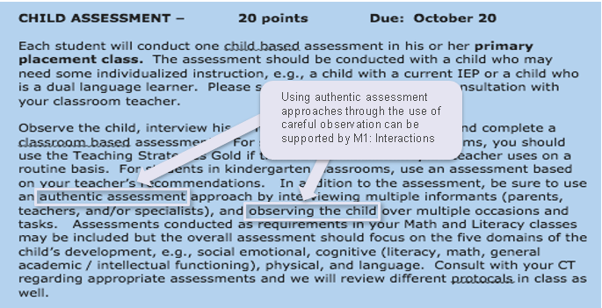

Observation Reports
This assignment focuses on observation skills to help improve multiple aspects of teaching young children. Module 1: Interaction supports learners in reading verbal and nonverbal cues of young children and objectively interpreting these observations for use in informing teaching practices and assessment.
See sample assignment below:
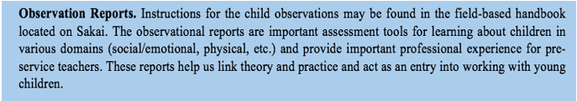

Internship Evaluation – Classroom Teaching and Professionalism
A student teacher’s success in the context of their internship setting is often connected to their ability to translate what is learned in the classroom to their practice. Module 1: Interaction supports learners in authentically translating content and research into their practice with young children. Module 1: Interaction can also assist supervisors to observe the quality of practices employed by their students in real-world contexts.
See sample assignment below:
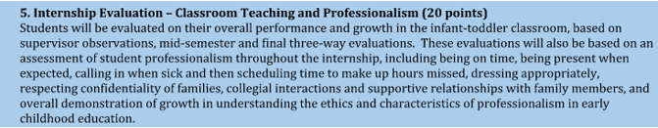
Examples of Course Schedules
These are examples of actual course schedules to show how professors and instructors can embed Module 1: Interaction into existing coursework, readings, and class sessions.
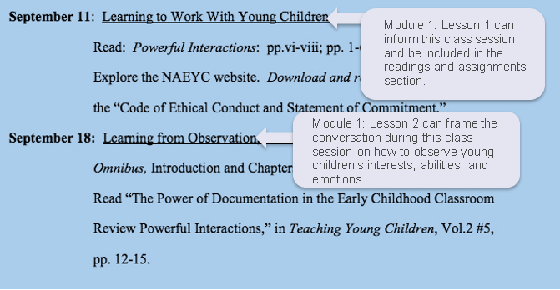

(From: http://steinhardt.nyu.edu/scmsAdmin/media/users/cdm385/Teaching_and_Learning_Syllabi/ECED-GE2002_Krasnow_F14.pdf)
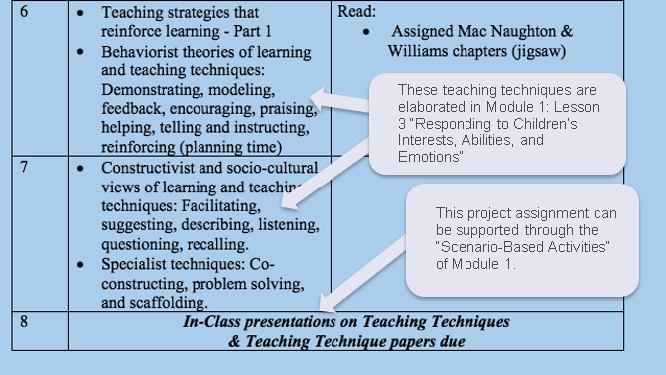
From: http://syllabi.gse.rutgers.edu/home/15-251#TOC-15:251:674---Practicum-in-Early-Childhood-Elementary-Education)

Field Experience Support
The following resources will assist supervisors or the student teachers themselves in assessing and providing feedback for field-based experiences.
- Interactions Observation Checklist
- Performance Feedback Guide
- Self-Reflection Tool

